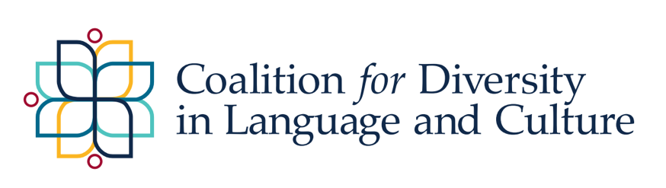
CDLC Grant Information

Application Deadline: December 1, 2023, by 11:59 pm

The Coalition for Diversity in Language and Culture (CDLC) provides competitive grants to support those engaged in research, grant writing and project implementation activities that fulfill the CDLC mission (http://cdlc.uncg.edu/). Individuals and groups including at least one UNCG tenured, tenure track, or professional track faculty may apply. Research groups are also encouraged to include graduate students.
CDLC Mission Statement:
The CDLC aims to be a catalyst for innovative, relevant, collaborative and policy-related research, leveraging the synergy and knowledge of faculty, staff, students, and communities, locally, nationally, and globally. Specifically, we propose to design and implement research agendas responsive to identified diverse language community needs that results in:
- Developing a coherent and comprehensive research agenda that engages community voices to address the educational and socio-cultural wellbeing of DLC individuals and groups.
- Establishing and strengthening partnerships among diverse language community stakeholders (e.g., individuals, families, students, schools, community organizations, universities, state policy makers).
- Building capacity to value and support international individuals, experiences, and perspectives and to promote global collaborations and opportunities.
- Advocating, promoting policy, and engaging in outreach activities to leverage positive change for DLCs through professional development, community engagement programs, and other avenues as needed for DLC stakeholders.

The CDLC is interested in supporting competitive submissions that:
- advance the knowledge base by engaging community voices to address the educational and sociocultural well-being of diverse language community individuals and groups.
- have direct benefit for members of a diverse language community.
- establish and strengthen partnerships among diverse language community stakeholders (e. g., individuals, families, students, schools, community organizations, universities, state policy makers).
- build capacity to value and support international individuals, experiences, and perspectives and to promote global collaboration and opportunities.
- advocate, promote policy, and engage in outreach activities to leverage positive change for diverse language communities through professional development, community engagement programs, and other avenues as needed for DLC stakeholders.

Applicants may submit proposals for activities including, but not limited to, the following:
- writing individual or collaborative papers (including white papers, policy briefs, technical reports, manuscripts, chapters) which will be disseminated in appropriate outlets.
- implementing professional development efforts (e.g., workshops, panels, interactive sessions) that are tied to research initiatives, leverage positive change for participants, and facilitate access and success.
- creating outreach materials (e. g., virtual materials, informational modules, pamphlets) that are tied to research initiatives and address the educational, psychological, and socio-cultural needs of individuals and groups from diverse language communities.
- building capacity within diverse language communities or addressing pressing needs as identified by community partners.

Submission Information
- Proposals must be no more than two, single-spaced pages and include: 1) the names and affiliations of all applicants; 2) goals/purposes, including how this aligns with the CDLC mission; 3) expected activities and outcomes, including the involvement of each member; and 4) a budget that outlines the plan for the allocation of funds.
- Submission: Please fill out this form and upload your proposal.
- Application Deadline: December 1, 2023, by 11:59 pm (Late applications will not be accepted.)
- Eligibility: Individuals or groups with at least one UNCG faculty (tenured, tenure track, or clinical)
- Award Amount: up to $3,000 per proposal
- At least two proposals will be funded.

Proposal Review and Funding
- Proposals will undergo blind review by a committee of CDLC members.
- All proposals will be evaluated based on their merit, with attention to explicit connections to the CDLC mission (http://cdlc.uncg.edu/) and clear statements of the scope of work to be completed during the grant period.
- Two or more applicants (all eligible as described above) may submit a collaborative application, but the funding will have to be shared as described in the proposal. The role of each collaborator must be clearly defined in the proposal.
- Priority will be given to proposals that align closely with the CDLC mission and that will use their funding in the community.
- Those who have received a CDLC Grant in the past are eligible to receive funding.
- For those previously funded, additional funding is contingent upon the completion of the final report for earlier projects and presentation of the project at either the CDLC Conference or another CDLC event.
- Fellowships will be announced no later than December 15, 2023. Funds will be transferred to the associated department and must be spent by April 30, 2024. All pertinent restrictions on the use of state funds will apply.

Other Guidelines
- CDLC Grant awardees are expected to use their funds as outlined in their proposal. If awardees decide to make changes to how funding is used, they will need to submit a revised plan for use of funds to be reviewed by the committee. At this time, the committee may decide to approve the changes, provide feedback for alternate plans, or rescind the offer altogether.
- CDLC Grant awardees should submit a final report (up to two, single-spaced pages) of their Fellowship activities by September 30, 2024, to Dr. Kelly Lowther Pereira, klpereir@uncg.edu. The report should describe the overall project and include information about how funds were used, the outcomes, and future directions. You are also encouraged to include photos to help document your project.
- Awardees may be asked to present/share the results of their work at the annual CDLC Conference. Awardees are also encouraged to present their work at the UNCG Undergraduate or Graduate Research and Creativity Expo.
- CDLC Grant awardees should include an acknowledgement of support from CDLC in all publications, presentations, and other materials resulting from the funded project. Suggested wording: This work was sponsored by the Coalition of Diversity in Language and Culture (CDLC) at UNC Greensboro (UNCG).
- Questions may be directed to: Dr. Kelly Lowther Pereira, klpereir@uncg.edu.

